The University of Jordan

Faculty of Engineering & Technology

Department of Civil Engineering



Environment Engineering Laboratory

0901472

Supervisor:

Eng. Awad Al-Kharabsheh

Eng. Heba Al-Kharabsheh

Coordinated by:

Qusai Al-Qudah



Table of Contents

INTRUDUCTION 2

DEFINITIONS 4

EXPERIMENT No.1: Power of Hydrogen 5

EXPERIMENT No.2: Acidity 7

EXPERIMENT No.3: Alkalinity 11

EXPERIMENT No.4: Chloride 15

EXPERIMENT No.5: Coagulation & Flocculation 18

EXPERIMENT No.6: Hardness 20

EXPERIMENT No.7: Softening 24

EXPERIMENT No.8: Total Solids 29

EXPERIMENT No.9: Chlorine & Ammonia 34

EXPERIMENT No.10: Dissolved Oxygen 37

EXPERIMENT No.11: Biochemical Oxygen Demand 40

EXPERIMENT No.12: Chemical Oxygen Demand 44

EXPERIMENT No.13: Coliform 46



INTRUDUCTION

Although they seem simple, many people initially have trouble with titrations. There is a good deal of eye-hand coordination involved and many small errors than can creep in to ruin your experiment. The following are some tips that should help you to be successful:

1. Add your base to the burette over the sink. If you try to add it in the burette clamp, some might spill into your acid sample and you would have to start over
2. Do not forget to put the indicator in your sample.
3. Make sure you setup your burette so the tip is below the top of the beaker.
4. Make sure you have no bubbles in the tip of your burette. This probably causes 75% of the problems students have with getting titrations to be reproducible.
5. When you see that the pink color starts to persist, the slow addition of base to a drop at a time
6. To get the best equivalence points, you will need to 'cut' drops. Barely open your stopcock and let less than a drop form on the tip. Then use your distilled water bottle to squirt it into the beaker. This will assure that you obtain lightest pink color that you can

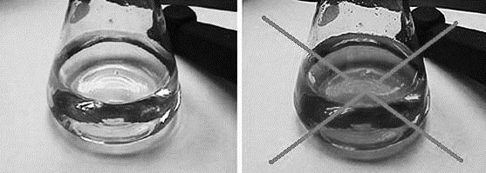

1. Your burette is a direct read delivery burette. This means, 'What You See Is What You Get'. If you start at 0.00ml and stop at 23.56ml, you used 23.56ml.
2. Very important: read all burette readings to 0.01ml! Remember, you always read to one place past what is marked on the measuring device. Also, make sure you look directly at the burette at eye level, do not look down or up to read the meniscus, and this will cause parallax errors.

The following figure shows an initial volume of 9.62mL and a final volume of 24.16ml:

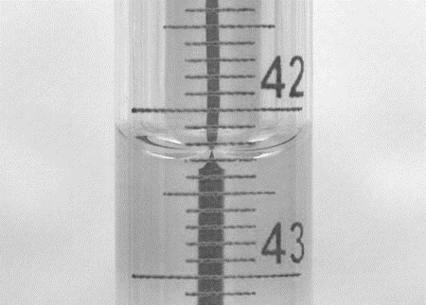

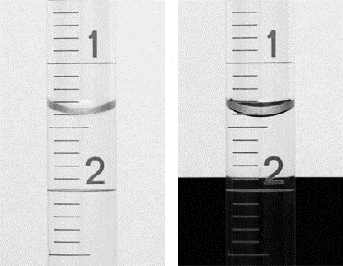

DEFINITIONS

* Morality: the concentration of the solution or the number of moles divided by volume of solution.
* Normality: the number of equivalent of solution.
* Equivalent weight: the mass of one equivalent.
* Molecular weight: the mass of a molecule or the sum of the mass of each constituent atom multiplied by the number of atoms of that element in the molecular formula
* Atomic weight: the mass of an atomic particle, sub-atomic particle, or molecule. It may be expressed in unified atomic mass units; by international agreement.

Such as: $CH_{4}$ the atomic mass of C is 12.0107A.W.U and for H is 1.00794A.W.U and the molecular weight of this solution is $1.00794*4+12.01074=16.04g/mole$.

* Avogadro number: the number of constituent particles (usually atoms or molecules) in one mole of a given substance, where mole is one of the seven base units in the International System of Units and its value is equal to $6.02214129×{10}^{23} mol^{-1}$.
* Buffer: an aqueous solution consisting of a mixture of a weak acid and its conjugate base or a weak base and its conjugate acid. Its pH changes very little when a small amount of strong acid or base is added to it and thus it is used to prevent changes in the pH of a solution. Buffer solutions are used as a means of keeping the pH at a nearly constant value in a wide variety of chemical applications. Many life forms thrive only in a relatively small pH range, so they utilize a buffer solution to maintain a constant pH. One example of a buffer solution found in nature is blood.
* Indicator: a chemical detector for protons in acid-base titrations.

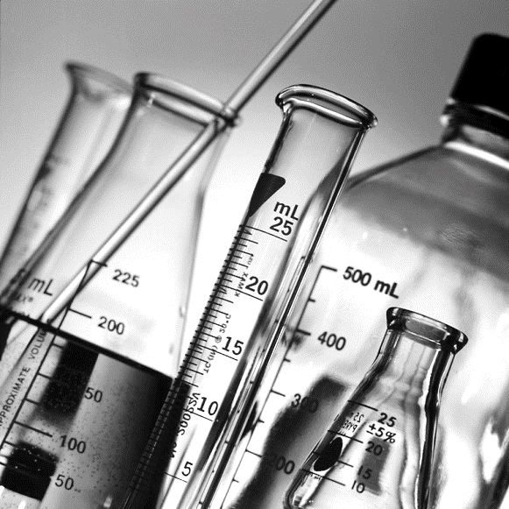

EXPERIMENT No.1: Power of Hydrogen

* General Discussion:-
* pH: the negative logarithm of the hydrogen ION (H+ or H3O+).
* Water with a pH value less than 7 indicates acidity and tends to be corrosive, while water with a value greater than 7 indicates alkalinity and tends to affect the taste of the water, pH of 7 is neutral
* Acidity or low pH of drinking water is usually a result of natural geological conditions at the site, possibly compounded by acid rain.
* Examples of acidic substances are vinegar and lemon juice. Lye, milk of magnesia, and ammonia are examples of basic substances.
* Testing of the pH of your well water is crucial for:

1. Evaluating the potential for your household plumbing to be subject to aggressive corrosion.
2. Evaluating the potential for your drinking water to contain leached metals such as copper, lead, iron, cadmium, and zinc from your well pump and plumbing system.
3. Determining the effects of proper home treatment of other drinking water contaminants. Depending on the pH level (how acidic or alkaline), pre-treatment may be needed to adjust the pH of your water to a more neutral range Otherwise, home treatment systems may not work as designed. Home treatment methods to adjust pH include Neutralizing Filters and neutralizing solutions (soda ash).

* The low of pH is ( $pH=-\log{H^{+}}$).
$$K_{w}: H_{2}O→H^{+}+OH^{-}$$

$$K_{w}=\frac{\left[H^{+}\right]\left[OH^{-}\right]}{\left[H_{2}O\right]}={10}^{-14}\left[H_{2}O\right]=1$$

$$-\log{(\left[H^{+}\right]\left[OH^{-}\right]=-\log{{10}^{-14}}}$$

$$-\log{(\left[H^{+}\right]\left[OH^{-}\right]=14}$$

$$-(\log\left[H^{+}\right]+log⁡[OH^{-}])=14 If(-log=P)$$

$$P_{H^{+}}+P_{OH^{-}}=14$$

* Significance:-

Potential Health Effects.

The pH of drinking water is not a health concern, however, acidic water (low pH) can leach metals from plumbing systems, which can cause health problems, Extremes of pH can defect the palatability of water, pH also affects fish and the values that depart increasingly from the normally found levels will have more effects on fish.

* Reagent:-

Buffer solutions for the calibration of the meter; such solutions can be prepared in the laboratory, more conveniently obtained from chemical supply house; they will be supplied at a PH value correct to the second decimal place. These solutions are not cheap and must be stored and treated with care. The buffer solutions to be used are listed below:

* Buffer solution pH=7:

BDH phosphate buffer (product No.19039) is suitable, as is a comparable equivalent.

* Buffer solution pH=9:

DBH borate buffer solution (product No.19041), or equivalent, may be used.

* Procedure:-

1. The meter should be setup and the electrodes prepared in accordance with the manufacturer's instructions. If the meter has been set up previously, check that there is an adequate filling solution in the reference electrodes, if not replenish with the cautions supplied by the manufacturer.
2. Standardize the meter using two buffer solutions (pH values 7 and 9) and adjust the meter controls as necessary to suit the temperature and the buffer solutions.
3. Wash the electrodes with distilled water and then the sample.
4. Measure the pH of a fresh portion of the sample, resetting the temperature if necessary.
5. Take care not to bring sample vessels into contact with the membrane (bulb) of the glass electrodes.
6. Wash the electrodes as mentioned above.

* Calculations of Results:-

The results are reported as obtained.

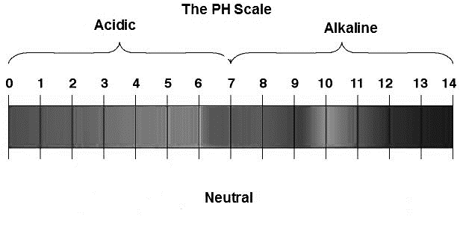

EXPERIMENT No.2: Acidity

* General Discussion:-
* Acidity defined as the capacity of water to donate protons, or as a measure of the amount of acid present in the water, or as the ability to neutralize bases.
* The degree of acidity is often responsible for the chemical behavior of substances present in solutions. For example, too much coffee or other food or drink sometimes causes gastric distress because of an acid imbalance in the stomach. A number of commercial antacid preparations are available to relieve this condition. In a number of instances, it is necessary to be able to accurately determine the concentration of an acid (or a base) present in a solution.
* The most common units for expressing solution concentration are molarity (M, moles of solute/liter of solution) and normality (N, equivalents of solute/liter of solution).
* Titration is a volumetric method of chemical analysis, which involves taking an accurately measured volume of an acid and adding base until the solution becomes neutral (has the same number of H+ ions as OH-ions). The point at which the amounts of acid and base become equivalent is called the "equivalence point" and is usually signaled by a color change caused by some acid sensitive dye (called an indicator) which has been added to the solution. The two solutions (one of acid, the other of base) are delivered using volumetric glassware (in this experiment the glassware is a burette) so that volumes will be accurately known. In addition, the concentration of either the acid or base must be accurately known (must be a standard solution).
* To be successful, a titration must involve a chemical reaction between the two solutions that are being mixed. This chemical reaction should be simple, rapid and complete. Although a titration may involve an acid base reaction, a precipitation reaction, a complex reaction, or an oxidation-reduction reaction, only the acid base reaction will be studied in this experiment.

http://www.lenntech.com/images/pH-and1.gif



* This reaction between an acid and a base is called neutralization. The base is added to the acid until the solution contains equivalent amounts of each. At this point, the acid is said to be "neutralized". If the proper chemical indicator has been added to the solution, a color change occurs. Using the measured volumes of the acid and base and the concentration of the "standard solution" (either acid or base), the concentration of the other reactant may be readily calculated from the equation:

(Volume of acid) (Normality of acid) = (Volume of base) (Normality of base)

$$V_{a}N_{a}=V_{b}N_{b}$$

* When using solutions of acids, bases and it is convenient to express concentration in terms of NORMALITY, the number of equivalents of solute in a liter of solution.
* Types of acidity:

1. CO2 Acidity.
2. Mineral Acidity.

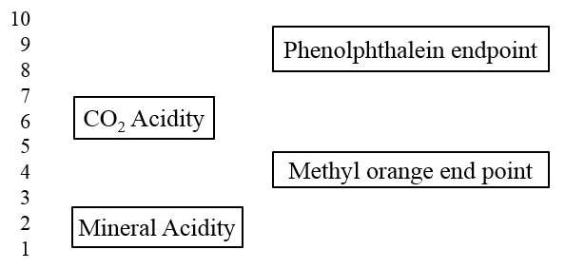

8.3

Colorless

Orange

Yellow

No acidity

4.5

* Where:
* Mineral Acidity: it is measured by titration with a pH of about 4, the methyl orange end.
* Total acidity: Titration of a sample to the phenolphthalein end point of pH 8.3 measures mineral acidity plus acidity due to weak acids.
* Apparatus:-

1. Burette.
2. Flasks.
3. pH meter.

* Reagent:-

Standard NaOH (0.02N); Dilute 20ml (1N) NaOH with distilled water to one litter.

1. Phenolphthalien indicator solution.
2. Methyl orange indicator solution.

* Procedure:-
* Dilute approximately 200ml of (1N) NaOH with approximately 800ml of distilled water in a 1000ml beaker. Rinse the graduated cylinder with distilled water and add to the beaker to make sure you get all of the NaOH.
* Titration of NaOH Solution:

1. Obtain a 50ml burette, close the stopcock and fill it to the top with distilled water.
2. Open the stopcock and allow all of the water to drain.
3. Close the stopcock and fill your burette with 50ml of your NaOH solution (from above) so that the solution meets the entire inner surface of the burette.
4. Open the stopcock and allow all of the NaOH to drain through the tip.
5. Fill the burette to the top with the NaOH. Open the stopcock all the way to flush all bubbles out of the tip. When all bubbles have been flushed out, (it may take several tries), close the stopcock and refill the burette.
6. Read the bottom of the meniscus and record the initial reading to the nearest 0.01ml. The Teflon stopcock should turn smoothly with a little resistance. If the stopcock is too loose, tighten it a little, otherwise the solution will leak around the stopcock and the titration will be for naught. A leaking burette is a major cause of error in titrations.
7. Add 2 drops of phenolphthalein indicator (ph.ph) to the acid solution. The solution should remain colorless (4.5 < pH < 8.3).
8. Rinse down the inside of the beaker occasionally and continue, slowly adding NaOH and measure the pH value for each addition until the first permanent, faint pink color persists for at least 30 seconds. At this point the titration is complete (the endpoint).
9. Read the final volume of NaOH and record to the nearest 0.01ml. Remember these are 'direct readers' burettes, what you see is what you get! Some of you may have used other burettes where they start at 50ml and go to zero, so you subtract your reading from 50. DO NOT do that with these burettes!

* If $pH<4.5$;

1. Add 2 drops of methyl orange indicator to the acid solution. The solution should be orange, titrate with NaOH until the color become yellow.
2. Repeat steps; 7, 8 and 9.

* Calculations of Results:-
$$Acidity=\frac{A*N*50,000}{Volume of sample (ml)}$$

* Where:

A: volume of solution hydroxide (ml).

N: normality of solution hydroxide.

* Total acidity is the sum of mineral acidity and CO2 acidity.
* Use unit: mg/l as CaCO3.

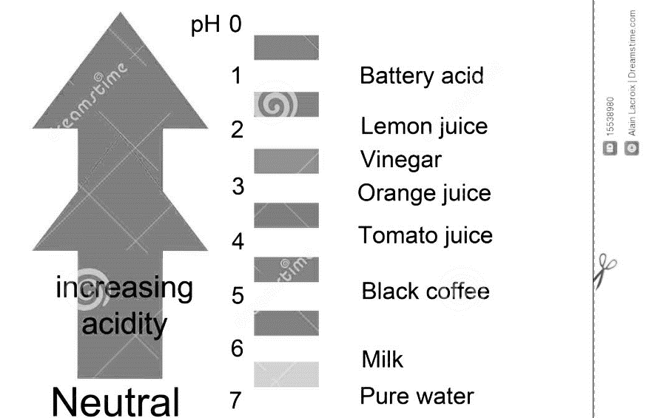

EXPERIMENT No.3: Alkalinity

* General Discussion:-
* The alkalinity of water may be defined as its capacity to neutralize acid. Alkali substances in water include hydroxides or bases. They can be detected by their acrid taste and by the fact that they cause red litmus paper to turn blue.
* Alkalinity comes from rocks and soils, salts, certain plant activities, and certain industrial wastewater discharge (detergents and soap-based products are alkaline.
* It is generally due to the presence of bicarbonates formed in reactions and carbonate which may also be present in natural waters, particularly those which are eutrophic, and this fact will tend to be reflected in higher pH values.
* To lower Total Alkalinity, adds Acid - The acid reacts with bicarbonates in the water and converts them, reducing the Total Alkalinity.
* To raise Total Alkalinity, add Sodium Bicarbonate - This adds to the total bicarbonates in the water, raising the Total Alkalinity.
* Type of alkalinity with respect to indicator:

1. Phenolphthalein endpoint.
2. Methyl orange endpoint.



Colorless

No alkalinity

8.3

Orange

Pink

Yellow

4.5

* Type of alkalinity with respect to Alkalinity species:

1. Hydroxide Alkalinity.
2. Carbonate Alkalinity.
3. Bicarbonate Alkalinity.

V

II

I

$$V_{1}$$

$V_{1}$ =0

$$V_{1}$$

$$V_{1}$$

$$V_{2}=0$$

$$V_{2}$$

$$V_{2}$$

$$V_{2}$$

$$V_{2}$$

$$V_{1}$$

III

IV

1. ${OH}^{-}$ Alkalinity: the color change from pink to yellow quickly without passing colorless step.
2. Carbonate Alkalinity $:V_{1}=V_{2}$.
3. ${OH}^{-}+{CO_{3}}^{-2}$ Alkalinity $: V_{1}>V_{2}$.
4. ${{HCO}_{3}}^{-}+{{CO}_{3}}^{-2}$ Alkalinity $: V_{1}<V_{2}$.
5. ${{HCO}_{3}}^{-1}$ Alkalinity:

$$pH<8.3 \text{like tab water}$$

* Significance:-
* Alkalinity is significant in many uses and treatments of natural waters and wastewater. It is important for fish and aquatic life because it protects or buffers against rapid pH changes. Higher alkalinity levels in surface waters will buffer acid rain and other acid wastes, and prevent pH changes that are harmful to aquatic life.
* Unpalatability may result in highly alkaline waters.
* Analytical method:-

An unaltered sample is titrated to an end point of pH=4.5 (as indicated by methyl orange). Samples should not be diluted, concentrated, preserved chemically or altered in any way. The method is applicable to drinking, surface and saline waters and to domestic and industrial wastes if the endpoint is not obscured by color or turbidity.

* Reagents:-
* Sulphuric Acid (0.02N); prepares from concentrated volumetric solution in accordance with supplier's instructions.
* Methyl Orange Indicator; Dissolve 0.1g methyl orange in 100 ml hot water and filter if necessary.
* Apparatus:-

1. Burette.
2. Flasks.
3. pH meter.

* Procedure:-

1. Obtain a 50ml burette, close the stopcock and fill it to the top with distilled water.
2. Open the stopcock and allow all of the water to drain.
3. Close the stopcock and fill your burette with 50ml of yoursH2SO4 solution (from above) so that the solution encounters the entire inner surface of the burette.
4. Open the stopcock and allow all of the H2SO4 to drain through the tip.
5. Fill the burette to the top with the H2SO4. Open the stopcock all the way to flush all bubbles out of the tip. When all bubbles have been flushed out, (it may take several tries), close the stopcock and refill the burette.
6. Read the bottom of the meniscus and record the initial reading to the nearest 0.01ml. The Teflon stopcock should turn smoothly with a little resistance. If the stopcock is too loose, tighten it a little, otherwise the solution will leak around the stopcock and the titration will be for naught. A leaking burette is a major cause of error in titrations.
7. Add 2 drops of Methyl Orange indicator (M.O) to the solution. The solution should be yellow (4.5 < pH < 8.3).
8. Rinse down the inside of the beaker occasionally and continue, slowly adding H2SO4 and measure the pH value for each addition until the first permanent, faint orange color persists for at least 30 seconds. At this point, the titration is complete (the endpoint).
9. Read the final volume of H2SO4and record to the nearest 0.01ml. Remember these are 'direct readers' burettes, what you see is what you get! Some of you may have used other burettes where they start at 50ml and go to zero, so you subtract your reading from 50. DONOT does that with these burettes!

* If $pH>8.3$;
  1. Add 2 drops of (ph.ph) indicator to the solution. The solution should be pink, titrate with H2SO4 until the color become colorless.
  2. Repeat steps; 7, 8 and 9.
* Calculations of Results:-
$$Alkalinity=\frac{A*N*50,000}{Volume of sample (ml)}$$

* Where:

A: volume of solution hydroxide (ml).

N: normality of solution hydroxide.

* Total Alkalinity is the sum of methyl orange Alkalinity and ph.ph Alkalinity.
* Use unit: mg/l as CaCO3.
* Interpretation of Results:-

Alkalinity values in some drinking water supplies may be very low, but this is a natural phenomenon rather than one induced as in softened water. From the viewpoint of river water quality, very high values are not significant; the alkalinity may be as high as 400mg/l in some cases.

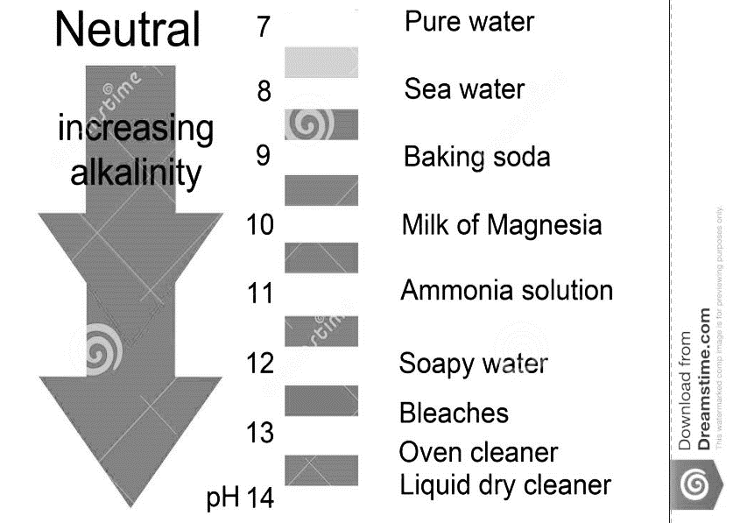

EXPERIMENT No.4: Chloride

* General Discussion:-
* Chloride exists in all natural waters, the concentrations vary very widely and reaching a maximum in seawater (over 33,000mg/l).
* In fresh waters, the sources include soil and rock formations, sea spray and waste discharges.
* Sewage contains large amounts of chlorides, as do some industrial effluents.
* Chloride is found naturally in groundwater through the weathering and leaching of sedimentary rocks and soils and the dissolution of salt deposits. Chloride is often attached to sodium, in the form of sodium chloride (NaCl), which is used extensively for snow and ice removal.
* Other sources of chloride in groundwater include:

1. Saltwater intrusion and sea spray in coastal areas.
2. Leachate from dumps or landfills.
3. Water softener backwash.
4. Sewage contamination.
5. Leachate from abandoned, deep exploration holes or mines (rare).
6. Soil and rock.

* Significance:-
* Chlorides do not pose a health hazard to humans and the principle consideration is its relation to palatability. At levels above 250mg/l, water will begin to taste salty and will become increasingly objectionable as the concentration rises further.
* External circumstances govern acceptability, and in some arid areas, waters containing up to 2,000mg/l Cl are consumed, though not by people unfamiliar with such concentrations. Because sewage is such source of chloride, a high result may indicate pollution of water by a sewage effluent.
* Analytical method:-
* Of the different titration methods available the Mohr method, which uses a standard silver nitrate solution is the most common.
* Potassium chromate is used as indicator. The method is applicable to drinking, surface and saline waters, and to wastes.
* Reagents:-
* Silver Nitrate (AgNO3, (N=0.0141), may be prepared in the laboratory or purchased at a concentration ready for dilution. In both cases, the reagent is photosensitive and must be stored either in a dark bottle or in a cupboard.
* Potassium Chromates Indicator (K2CrO4).
* Chemistry:-
* For the unknown sample: (Mohr method for chloride)

This approach relies KSP difference for two insoluble silver salts

$Ag^{+}+Cl^{-}→AgCl$, Titration reaction

$2Ag^{+}+CrO_{4}^{-2}→Ag_{2}CrO_{4}$ At end point

* AgCl is much less than soluble than AgCr2O4, so it will precipitation first.
* AgCr2O4 is brick-red in color so a color change is observed at the end point.
* For the distilled water (Blank sample):

$$2Ag^{+}+CrO_{4}^{-2}→Ag_{2}CrO_{4}$$

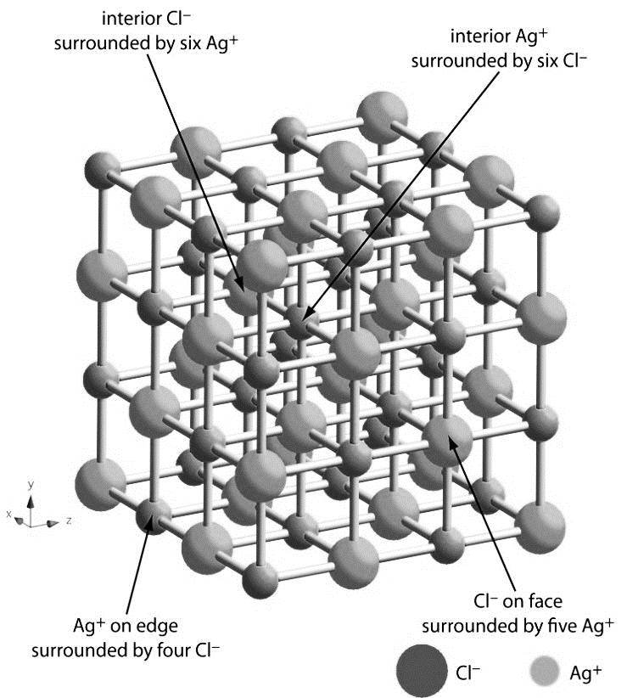

* Precautions:-
* Store the Silver Nitrate in the dark when not in use; otherwise it will deteriorate, and a brown color appears.
* Spillages of Silver Nitrate on the hands should be washed off immediately, otherwise staining of the skin will occur.
* The addition of a small amount of kaolin to the conical flasks sometimes aid to the detection of the end point.
* Procedure:-

1. Put 100ml of the sample in 250ml conical flask.
2. Add 10 drops of (K2CrO4) indicator.
3. Fill the burette with Silver Nitrate (AgNO3), N=0.0141.
4. Add slowly toa shaking Silver Nitrate solution to the end point is reached. The end point is when a definite red-brown precipitate appears.
5. Note the volume used (A).
6. Repeated the steps for 100ml of distilled water (Blank sample).
7. Note the second volume (B).

* Calculations of Results:-
$$CL=\frac{(A-B)*N*35,450}{Volume of sample (ml)}$$

* Where:

A: volume of silver nitrate from tap water sample (ml).

B: volume of silver nitrate from distill water sample (ml).

N: normality of silver nitrate.

* Use unit: mg/las Cl.
* Interpretation of Results:-
* Natural levels in rivers and other fresh waters are usually in the range 15-35mg/l $Cl^{-}$ much below drinking water standards.
* What is normally important to note in a series of results from a river, for example, is not the absolute level, but rather the relative levels from one sampling point to another.
* An increase of even 5mg/l at one station may be enough to cause suspicions of a sewage discharge, especially if the free ammonia levels are also elevated.

EXPERIMENT No.5: Coagulation & Flocculation

* General Discussion:-
* Groundwater and surface water contain both dissolved and suspended particles. Coagulation and flocculation are used to separate the suspended solids portion from the water.
* Suspended particles vary in source, charge, particle size, shape, and density. Correct application of coagulation and flocculation depends upon these factors. Suspended solids in water have a negative charge and since they have the same type of surface charge, they repel each other when they come close together. Therefore, suspended solids will remain in suspension and will not clump together and settle out of the water, unless proper coagulation and flocculation is used.
* Coagulation and flocculation occurs in successive steps, allowing particle collision and growth of weight. This is then followed by sedimentation (see Sedimentation Chapter). If coagulation is incomplete, flocculation step will be unsuccessful, and if flocculation is incomplete, sedimentation will be unsuccessful
* Coagulation:-
* Coagulant chemicals with charges opposite those of the suspended solids are added to the water to neutralize the negative charges on non-settable solids (such as clay and color-producing organic substances).
* Once the charge is neutralized, the small suspended particles are capable of sticking together. These slightly larger particles are called micro-weights, and are not visible to the naked eye. The Water surrounding the newly formed micro-weights should be clear. If not, coagulation and some of the particle’s charges have not been neutralized. More coagulant chemicals may need to be added.
* A high-energy, rapid-mix to properly disperse coagulant and promote particle collisions is needed to achieve good coagulation. Over-mixing does not affect coagulation, but insufficient mixing will leave this step incomplete. Contact time in the rapid-mix chamber is typically 1 to 3 minutes.
* Flocculation:-
* Flocculation, a gentle mixing stage, increases the particle size from submicroscopic micro-weight of visible suspended particles. Micro-weight particles collide, causing them to bond to produce larger, visible weights called pin-weights. Weight size continues to build with additional collisions and interaction with added inorganic polymers (coagulant) or organic polymers. Macro-weights are formed and high molecular weight polymers, called coagulant aids, may be added to help bridge, bind, and strengthen the weight, add weight, and increase settling rate. Once weight has reached it optimum size and strength, water is ready for sedimentation.
* Design contact times for flocculation range from 15 or 20 minutes to an hour or more, and flocculation requires careful attention to the mixing velocity and amount of mix energy. To prevent weight from tearing apart or shearing, the mixing velocity and energy are usually tapered off as the size of weight increases. Once weights are torn apart, it is difficult to get them to reform to their optimum size and strength. The amount of operator control available in flocculation is highly dependent upon the type and design of the equipment.
* Turbidity:-
* Coagulant:

1. Alum.
2. Ferric Chloride.
3. Ferrous Sulfate.
4. Lime.
5. Soda Ash.
6. Polymer.

* To get Optimum Turbidity:

1. Constant dose $→$ optimum pH $→$ lowest turbidity.
2. Constant pH $→$ optimum dose $→$ lowest turbidity.

EXPERIMENT No.6: Hardness

* General Discussion:-
* Tap water in some parts of the country is very pure and is said to be ‘soft’. It easily makes lather with soap. Water from other parts may contain various dissolved impurities and is described as ‘hard’ water.
* Hard drinking water is generally not harmful to one's health, but can pose serious problems in industrial settings, where water hardness is monitored to avoid costly breakdowns in boilers, cooling towers, and other equipment that handles water. In domestic settings, hard water is often indicated by a lack of suds formation when soap is agitated in water, and by the formation of lime scale in kettles and water heaters. Wherever water hardness is a concern, water softening is commonly used to reduce hard water's adverse effects.
* When treated hard water with soap, it gets precipitated in the form of insoluble salts of Calcium Ca+2and MagnesiumMg+2Hardness of water is a measure of the total concentration of Calcium & Magnesium ions as a Calcium CarbonateCaCO3.
* Water's hardness is determined by the concentration of multivalent cations in the water. Multivalent cations are cations (positively charged metal complexes) with a charge greater than 1+. Usually, the cations have the charge of 2+. Common cations found in hard water include Ca+2andMg+2. These ions enter a water supply by leaching from minerals within an aquifer. Common calcium-containing minerals are calcite and gypsum. A common magnesium mineral is dolomite (which also contains calcium). Rainwater and distilled water are soft, because they contain few ions.
* Problem with hard water:

1. Laundering.
2. Bathing.
3. Dishwashers.
4. Problems in water boilers system and pipe works.

* Types of hardness of water with respect to permanency:

1. Temporary hardness: is due to the presence of Bicarbonates HCO3 of Calcium & Magnesium. It can be easily removed by boiling.
2. Permanent hardness: is due to the presence of Chloride (Cl), Sulfates SO3-2of Calcium, and Magnesium. This type cannot be removed by boiling.

* Types of Hardness with respect to divalent cations:

1. Ca+2 Hardness.
2. Mg+2 Hardness.

* Types of Hardness with respect to Alkalinity species:

1. Carbonate hardness.
2. Non-Carbonate hardness.

* Significance:-
* Hardness is a natural characteristic of water that can enhance its palatability and consumer acceptability for drinking purposes.
* Health studies in several countries in recent years appear to indicate that mortality rates from heart diseases is lower in areas with hard water supplies. The chief disadvantages of hard waters are that they neutralize the lathering power of soap (though not modern detergent formulations) and more important that they can cause blockage of pipes and severely reduced boiler efficiency because of scale formulations.
* The following is one classification of water by hardness:

|  |  |
| --- | --- |
| Concentration (ppm) | Hardness rating |
| Soft | ≤50 |
| Moderately | 51-100 |
| Slightly Hard | 101-150 |
| Moderately Hard | 151-250 |
| Hard | 251-350 |
| Excessively Hard | >350 |

* Analytical method:-

Hardness is now measured by titration with EDTA in the presence of an indicator and at the correct pH value; the method is applicable to all waters and waste waters.

* Chemistry:-
* The titration reagent for hardness ions is EDTA (Sodium salt), invariably refer to as EDTA.
$$\begin{matrix}Na OOC-{CH}_{2 } \\ Na OOC-{CH}_{2}\end{matrix}\begin{matrix}↘ \\ ↗\end{matrix} N-\begin{matrix}H \\ C \\ H\end{matrix}-\begin{matrix}H \\ C \\ H\end{matrix}-N \begin{matrix}↙ \\ ↖\end{matrix}\begin{matrix}{CH}_{2}-COO Na \\ {CH}_{2}-COO Na\end{matrix}$$

* This form a stable complex with Calcium Andreanesiur ions which may be represented by:
$$M^{+2}+EDTA→{\left[M.EDTA\right]}_{Comples}$$

* Where M is the metal causing hardness EDTA also forms complex with organic dyes that are much weaker and hence will not be present before the reaction between the EDTA and the hardness is complete. Only then will the free indicator form a complex with EDTA, causing a change in color from red to blue.
* The general reaction is:
$$\begin{matrix}Indicator+EDTA \\ Red\end{matrix}→\begin{matrix}{\left[Ind.EDTA\right]}_{Complex} \\ Blue\end{matrix}$$

* It is applicable to the determination of both total hardness and Calcium hardness but different indicator are used.

|  |  |  |
| --- | --- | --- |
|  | Ca+2Hardness | Total Hardness |
| Titration | EDTA | EDTA |
| Indicator | Muroxide | EBT |
| pH range | 12-13 | 9.5-10.5 |
| Buffer | NaOH | Ammonium |

* Procedure:-
* Total Hardness:

1. Take 100 ml of sample.
2. Measure the pH value
3. Raise the pH to the correct range (9.5-10.5), using Ammonia buffer.
4. Put the indicator [EBT] (pink).
5. Fill the burette with [EDTA].
6. Titrate with [EDTA] until reaching the end point (blue).
7. Notice the volume of [EDTA] used.

* Calcium Hardness:

1. Take 100 ml of sample.
2. Measure the pH value
3. Raise the pH to the correct range (12-13), using Sodium hydroxide (NaOH) buffer.
4. Put the indicator [Muroxide] (pink).
5. Fill the burette with [EDTA].
6. Titrate with [EDTA] until reaching the end point (purple).
7. Notice the volume of [EDTA] used.

* Calculations of Results:-

$$Total Hardness=\frac{A*B*1000}{ml of sample}$$

Where:

A: volume of titration from EDTA.

B: mg $CaCO_{3}$ eq. to 1.0 ml EDTA.

Results are expressed asmg/l as CaCO3.

Where:

A: volume of titration from EDTA.

B: mg eq. to 1.0 ml EDTA.

Results are expressed asmg/l as CaCO3.

.

EXPERIMENT No.7: Softening

* General Discussion:-
* Water softening is the removal of calcium, magnesium, and certain other metal cations in hard water. The resulting soft water is more compatible with soap and extends the lifetime of plumbing.
* There are four methods to make soft water:

1. Ion exchange:

Conventional water-softening appliances intended for household use depend on an ion-exchange resin in which "hardness ions" mainlyCa+2 and Mg+2are exchanged for sodium ions. Ion exchange devices reduce the hardness by replacing magnesium and calcium with sodium or potassium ions (Na+ and K+).

1. Chelating agents:

Chelators are used in chemical analysis, as water softeners, and are ingredients in many commercial products such as shampoos and food preservatives. Citric acid is used to soften water in soaps and laundry detergents. A commonly used synthetic chelator is ethylenediaminetetraacetic acid (EDTA).

1. Distillation and rain water:

Since Ca+2and Mg+2exist as nonvolatile salts, they can be removed by distilling the water. Distillation is too expensive in most cases. Rainwater is soft because it is naturally distilled during the water cycle of evaporation, condensation and precipitation.

1. Lime softening.

* Significance:-
* It is often desirable to soften hard water. Most detergents contain ingredients that counteract the effects of hard water on the surfactants. For this reason, water softening is often unnecessary.
* Where softening is practiced, it is often recommended to soften only the water sent to domestic hot water systems to prevent or delay inefficiencies and damage due to scale formation in water heaters.
* Chemistry:-
* Softening can be achieved by adding lime in the form of limewater [Ca(OH)2], which in a carbonation reaction with CO2, forms calcium carbonate precipitate,
$$CO_{2}+Ca(OH)_{2}→CaCO_{3}↓+H_{2}O$$

* Reacts next with multivalent cations to remove carbonate hardness, the process requires re-carbonation through the addition of carbon dioxide to lower the pH which is raised during the initial softening process.
* As lime is added to raw water, the pH is raised and the equilibrium of carbonate species in the water is shifted. Dissolved carbon dioxide (CO2) is changed into bicarbonate (HCO3-) and then carbonates (CO3-2). This action causes calcium carbonate to precipitate due to exceeding the solubility product.
$Ca(HCO_{3})_{2}+Ca(OH)_{2}→CaCO_{3}↓+{2H}_{2}O$

* Additionally, magnesium can be precipitated as magnesium hydroxide in a double displacement reaction.
$Mg{\left(HCO_{3}\right)}_{2}+Ca(OH)_{2}→CaCO_{3}↓+MgCO_{3}$

$MgCO_{3}+Ca(OH)_{2}→Mg(OH)_{2}↓+CaCO_{3}$

* then reacts with anions to replace the non-carbonate hardness due to multivalent cations with non-carbonate hardness due to magnesium;
$MgSO_{4}+Ca(OH)_{2}→Mg(OH)_{2}↓+CaSO_{4}$

$CaSO_{4}+Na_{2}CO_{3}→CaCO_{3}↓+Na_{2}SO_{4}$

* then reacts with anions to replace the non-carbonate hardness due to multivalent cations with non-carbonate hardness due to calcium;
$CaSO_{4}+Na_{2}CO_{3}→CaCO_{3}↓+Na_{2}SO_{4}$

$$Or$$

$CaCl_{2}+Na_{2}CO_{3}→CaCO_{3}↓+2NaCl$

* The process is interesting in that both the calcium (and to an extent magnesium) in the raw water as well as the calcium added with the lime are both precipitated. This is in contrast to ion exchange softening where sodium is exchanged for calcium and magnesium ions. In lime softening, there is a substantial reduction in total dissolved solids (TDS). In ion exchange softening (sometimes referred to as zeolite softening), there is no significant change in the level of TDS.
* Lime softening can also be used to remove the following iron, manganese, radium and arsenic from water.
* Calculations of lime & soda ash doses:-

|  |  |  |
| --- | --- | --- |
|  | Lime | Soda Ash |
| $$CO_{2}$$ | X | - |
| $$Ca(CH)$$ | X | - |
| $$Mg(CH)$$ | 2X | - |
| $$Mg(NCH)$$ | X | X |
| $$Ca(NCH)$$ | - | X |
|  | $$\sum{Lime}$$ | $$\sum{Soda Ash}$$ |

* From equation “1”: for one eqt.wt of ${CO}_{2}$, we need one eqt.wt of lime.
* From equation “2”: for one eqt.wt of $Ca(HCO_{3})_{2}$, we need one eqt.wt of lime.
* From equation “3” & “4”: for one eqt.wt of $Mg(HCO_{3})_{2}$, we need two eqt.wt of lime.
* From equation “5” & “6”: for one eqt.wt of $MgSO_{4}$, we need one eqt.wt of lime + one eqt.wt of Soda ash.
* From equation “7”: for one eqt.wt of $CaSO_{4}$, we need one eqt.wt of Soda ash.
* Procedure:-

1. Calculate lime and Soda ash doses.
2. Add doses to the sample
3. Rapid mix the sample for 2 minutes @ 100rpm(Coagulation).
4. Slow mix the sample for 15 minutes @ [20-30] rpm(Flocculation).
5. Settling for 30 minutes at least.
6. Take sample from the supernatant, measure the total hardness, and compare with the initial.

* Example 1:-

$Ca=200mg/l as CaCO_{3}$

$Mg=100mg/l as CaCO_{3}$

$Alklinity=190mg/l as CaCO_{3}$

$CO_{2}=0.2m.eqt/l$

Solution:-

$Ca=200 mg/l as CaCO_{3}=200/50=4m.eqt/l$

$Mg=100 mg/l as CaCO_{3}=100/50=2m.eqt/l$

$Alklinity=190 mg/l as CaCO_{3}=190/50=3.8m.eqt/l$

$CO_{2}=0.2m.eqt/l$

0.2

0

6

4

|  |  |  |  |
| --- | --- | --- | --- |
| $$CO_{2}$$ | $$Ca^{+2}$$ | | $$Mg^{+2}$$ |
|  | Alkalinity | $$SO_{4}^{-2}$$ | |

3.8

$Ca\left(CH\right)=3.8m.eqt/l$

$Mg\left(CH\right)=0$

$Ca\left(NCH\right)=4-3.8=0.2m.eqt/l$

$Mg\left(NCH\right)=6-3.8=2m.eqt/l$

|  |  |  |
| --- | --- | --- |
|  | Lime | Soda Ash |
| $$CO_{2}$$ | 0.2 | - |
| $$Ca(CH)$$ | 3.8 | - |
| $$Mg(CH)$$ | 0 | - |
| $$Mg(NCH)$$ | 2 | 2 |
| $$Ca(NCH)$$ | - | 0.2 |
| $$\sum{X}$$ | 6 | 2.2 |

$\sum{Lime=0.2+3.8+0+2=6m.eqt/l}$

$\sum{Soda ash=0.2+2=2.2m.eqt/l}$

* Example 2:-

$Ca=80mg/l as Ca$

$Mg=24mg/l as Mg$

$Alklinity=220mg/l as CaCO_{3}$

$CO_{2}=0.2m.eqt/l$

Solution:-

$Ca=80mg/l as Ca=80/20=4m.eqt/l$

$Mg=24mg/l as Mg=24/12=2m.eqt/l$

$Alklinity=220mg/l as CaCO_{3}=220/50=4.4m.eqt/l$

$CO_{2}=0.2m.eqt/l$

0.2

0

6

4

|  |  |  |  |
| --- | --- | --- | --- |
| $$CO_{2}$$ | $$Ca^{+2}$$ | $$Mg^{+2}$$ | |
|  | Alkalinity | | $$SO_{4}^{-2}$$ |

4.4

$Ca\left(CH\right)=4m.eqt/l$

$Mg\left(CH\right)=0.4m.eqt/l$

$Ca\left(NCH\right)=0$

$Mg\left(NCH\right)=6-4.4=1.m.eqt/l$

|  |  |  |
| --- | --- | --- |
|  | Lime | Soda Ash |
| $$CO_{2}$$ | 0.2 | - |
| $$Ca(CH)$$ | 4 | - |
| $$Mg(CH)$$ | 2*0.4 | - |
| $$Mg(NCH)$$ | 1.6 | 1.6 |
| $$Ca(NCH)$$ | - | 0 |
| $$\sum{X}$$ | 6.6 | 1.6 |

$\sum{Lime=0.2+4+0.8+1.6=6.6m.eqt/l}$

$\sum{Soda ash=.6+0=1.6m.eqt/l}$

EXPERIMENT No.8: Total Solids

* General Discussion:-
* Solids: all thing in water “not liquid” except water.
* We can classify the solids as:
* Total solids:
* Can be defined as the total content of suspended and dissolved solids in water, (anything in water except water).
* The total solids also composed of two components, volatile and fixed solids.
* Total Dissolved Solids:
* (Often abbreviated TDS) is a measure of the combined content of all inorganic and organic substances contained in a liquid in molecular, ionized or micro-granular (colloidal sol) suspended form.
* Generally, the operational definition is that the solids must be small enough to survive filtration through a filter with two-micrometer (nominal size or smaller) pores.
* Total dissolved solids are normally discussed only for freshwater systems, as salinity comprises some of the ions constituting the definition of TDS. The principal application of TDS is in the study of water quality for streams, rivers and lakes, although TDS is not generally considered a primary pollutant (e.g. it is not deemed to be associated with health effects) it is used as an indication of aesthetic characteristics of drinking water and as an aggregate indicator of the presence of a broad array of chemical contaminants.
* Primary sources for TDS in receiving waters are agricultural and residential runoff, leaching of soil contamination and point source water pollution discharge from industrial or sewage treatment plants.
* Total dissolved solids are differentiated from total suspended solids (TSS), in that the latter cannot pass through a sieve of two micrometers and yet are indefinitely suspended in solution.
* Total suspended solids:
* Is a water quality measurement usually abbreviated TSS.
* This parameter was at one time called non-filterable residue (NFR), a term that refers to the identical measurement: the dry-weight of particles trapped by a filter, typically of a specified pore size. However, the term "non-filterable" suffered from an odd (for science) condition of usage: in some circles (Oceanography, for example) "filterable" meant the material retained on a filter, so non-filterable would be the water and particulates that passed through the filter. In other disciplines (Chemistry and Microbiology for examples) and dictionary definitions, "filterable" means just the opposite: the material passed by a filter, usually called "Total dissolved solids" or TDS. Thus, in chemistry the non-filterable solids are the retained material called the residue.
* Total Volatile solids:

The volatile solids are organic compounds of animal or plant origin. Biological processes can treat these.

* Total Fixed solids:

The fixed solids are things such as sand, gravel, and salt.

* Settle-able solids:

Refers to material of any size that will not remain suspended or dissolved in a holding tank not subject to motion, and excludes both TDS and TSS. Settleable solids may include larger particulate matter or insoluble molecules.

* Significance:-
* High TDS levels generally indicate hard water, which can cause scale buildup in pipes, valves, and filters, reducing performance and adding to system maintenance costs. These effects can be seen in aquariums, spas, swimming pools, and reverse osmosis water treatment systems. Typically, in these applications, total dissolved solids are tested frequently, and filtration membranes are checked in order to prevent adverse effects.
* Water can be classified by the amount of TDS per liter:

|  |  |
| --- | --- |
| Water type | TDS |
| Fresh | <1000mg/l |
| Brackish | 1000-10,000mg/l |
| Saline | 10,000-30,000mg/l |
| Brine | >30,000mg/l |

While a TDS of 5,000 mg/l is the minimum threshold for a water to be considered brine, the typical range is 30,000 to 100,000 mg/l.

* Procedure & Calculations:-
* Total solids:

1. Put the wastewater sample in an empty dish with a known w.t (w1).
2. Dry the sample in the oven @ temperature 103.
3. Weight the dried sample w2.

* Total Fixed solids:

1. Put the weighted sample w2 in the oven @ temperature. 550.
2. Weight the dried sample w3.

* Total Volatile solids:
$$T.V.S=T.S-T.F.S$$

$$T.V.S=\frac{w_{2}-w_{3}}{V}=\frac{g}{l}=\frac{mg*{10}^{3}}{l}$$

* Dissolved solids:

1. Filtrate the wastewater sample using filter paper and vacuum pump;

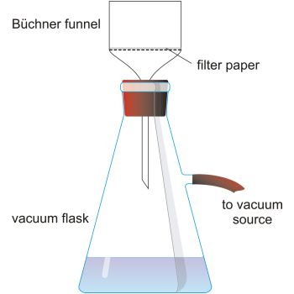

1. Put the passing sample from the filter paper into a dish with known w.t w4.
2. Dry the sample in the oven @ temperature 103.
3. Weight the dried samplew5.

* Dissolved Fixed solids:

1. Put the weighted sample w5 in the oven @ temperature. 550.
2. Weight the dried sample w6.

* Dissolved Volatile solids:
$$D.V.S=D.S-D.F.S$$

$$D.V.S=\frac{w_{5}-w_{6}}{V}=\frac{g}{l}=\frac{mg*{10}^{3}}{l}$$

* Suspended solids:

1. Weight an empty filter paper w7.
2. Take the filter paper after the filtration process.
3. Dry it in the oven @temp. 103 $℃$.
4. Weight the dried filter paper with the wastewater sample w8.

* Suspended Fixed solids:

1. Put the weighted sample w8 in the oven @ temperature. 550.
2. Weight the dried sample w9.

* Suspended Volatile solids:

$$S.V.S=S.S-S.F.S$$

$$S.V.S=\frac{w_{8}-w_{9}}{V}=\frac{g}{l}=\frac{mg*{10}^{3}}{l}$$

EXPERIMENT No.9: Chlorine & Ammonia

* General Discussion:-
* Microorganisms can be found in raw water from rivers, lakes and groundwater. While not all microorganisms are harmful to human health, some may cause diseases in humans. These are called pathogens. Pathogens present in water can be transmitted through a drinking water distribution system, causing waterborne disease in those who consume it.
* In order to combat waterborne diseases, different disinfection methods are used to inactivate pathogens. Along with other water treatment processes such as coagulation, sedimentation, and filtration, chlorination creates water that is safe for public consumption.
* Chlorination is one of many methods that can be used to disinfect water. This method was first used over a century ago, and is still used today. It is a chemical disinfection method that uses various types of chlorine or chlorine-containing substances for the oxidation and disinfection of what will be the potable water source. Chlorine that exists in water as hypochlorous acid and hypochlorite ion is defined as free available chlorine.
* Water supplies are chlorinated to deactivate microorganism which can be produce diseases such as Cholera, typical and so on, chlorine is reactive and isn’t constituent in natural water.
* Chlorine is used to combat microbial contamination, but it can react with organic matter in the water and form dangerous, carcinogenic Trihalomethanes.
* Chlorine is a versatile and low-cost disinfectant appropriate for any size water system, whether it serves a remote rural village or a large modern city. Where piped water supplies are not available, chlorine can also be used for treating water in individual households.
* Ammonia is generally present in natural water, through in very small amount, normally as a results of micro-degradable activity which cases the reduction of nitrogen captaining compounds.
* The state of the ammonia-weather is free as $NH_{3}$ or solution as $NH_{4}$ in slightly acid water, that isdepending on the pH and those forms distinguished from are other by analysis.
* Significance:-
* There are alternative methods for water disinfection such as;

1. Ozonation.
2. UV radiation.

* The advantage of chlorine in comparison to ozone and UV radiation is that the residual persists in the water for an extended period of time. This feature allows the chlorine to travel through the water supply system, effectively controlling pathogenic backflow contamination. In a large system this may not be adequate, and so chlorine levels may be boosted at points in the distribution system, or chloramine may be used, which remains in the water for longer before reacting or dissipating.
* Analytical method:-

There is a several procedure for chlorine analysis principally colorimetric. A common reagent used in the past has been orthotolidine, which is now proscribed an carcinogenic substance, it used should be avoided, the detailed below used the reagent DPD (N , N – diethyl phenolphthalein), and is convenient fellow.

* Procedure for chlorine test:-

1. Prepare the sample that will be tested by adding orthotolodine (O.T) to it.
$$Cl_{2}+O.T→Complex (yellow)$$

2. Put a blank sample (distilled water) and the sample that will be tested in the lovibond device.

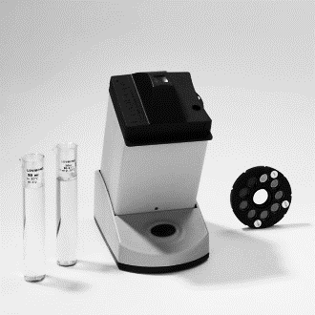

Blank

Sample

1. Put the lovibond disk (for chlorine) and compare the colors of the two samples until reaching the same color.
2. Read the concentration of chlorine related to the selected color in (mg/l).

* Procedure for Ammonia test:-

Ammonia is found as NH3,N (ϻg/l).

1. Prepare the sample that will be tested by adding Nessler reagent (N.R) to it.
$$NH_{3}+N.R→Complex (yellow)$$

2. Put a blank sample (distilled water) and the sample that will be tested in the Lovibond device.
3. Put the lovibond disk (for Ammonia) and compare the colors of the two samples until reaching the same color.
4. Read the concentration of Ammonia related to the selected color in (ϻg/l) NH3.

EXPERIMENT No.10: Dissolved Oxygen

* General Discussion:-
* Oxygen gas dissolved in water is vital to the existence of most aquatic organisms. Oxygen is a key component in cellular respiration for both aquatic and terrestrial life. The concentration of dissolved oxygen, D.O, in an aquatic environment is an important indicator of the environment’s water quality.
* Dissolved oxygen is a molecule of O2 that is dissolved into the water. It is invisible to our naked eye. It is not the bubbles in water, nor the oxygen component of the water molecule H2O. Dissolved oxygen can get into the water two ways, through atmospheric oxygen mixing into a stream in turbulent areas or by the release of oxygen from aquatic plants during photosynthesis.
* The measurement of dissolved oxygen (D.O) is significant in respects;

1. As a laboratory test, it forms the basis of the biochemical oxygen demand (B.O.D) analysis that is fundamental to both water quality assessment and the examination of wastewaters.
2. Determination of biological changes by aerobic or anaerobic organisms.
3. Check on pollution.
4. To assess quality of raw water.
5. All aerobic biological wastewater treatment processes
6. Corrosion control.

* Factors that effect on dissolved oxygen:

1. Temperature.
2. Pressure.
3. Altitude.
4. Pollution.
5. Salinity.

* Significance:-
* Adequate levels of D.O are essential for fish life, although the saturation concentration of oxygen in water at 20℃ is only 9.2mg/l this level will support the flora and fauna found in an unpolluted river. As levels drop, whether because of pollution or of a phenomenon such as eutrophication, fish will be affected adversely.
* Oxygen in water varies inversely with the temperature so that in summer levels will be at a minimum. Consequently, waters are at their greatest risk from pollution in warm weather.
* Analytical method-Field Measurement:-

D.O is measured most accurately and conveniently in the field by means of an Oxygen electrode copied to a suitable meter.

* Procedure:-
* The manufacturer's instructions should be followed precisely.
* Meters and electrodes must be handled with great care and be protected against wet and damp. While some electrodes have a removable cage to guard against damage it still very easy to damage the thin polythene membrane that covers the electrode.
* If the membrane is punctured, D.O. measurements are impossible and while the cost of replacement material is low, a considerable time may be needed to replace the membrane and recalibrate the instrument.
* Analytical method-Laboratory Measurement:-
* The universal method for D.O. measurement in the laboratory is the Winkler (iodmoetric) method in which the Oxygen reacts with a series of chemicals to yield a solution of iodine, the concentration of which is directly proportional to the D.O.
* There are several modification of the method, that below being the Alsterberg or Azide modification.
* Procedure:-
  1. Fill the bottle (300ml) of the sample.
  2. Add to the sample 1ml of MnSO4 (to check existence and fixation of oxygen molecular).
  3. Add 1ml of (Alkali-Iodide-Azide) reagent $; NaOH+KI+NaN_{3}$.
  4. Mixing then the brown color appeases.
  5. Add 1ml of H2SO4(pure), (to increase the temperature of the sample and make an acidic media).
  6. Titration with thiosulfate “Na2S2O3” (with N=0.0125) then the color becomes colorless.

1. Record the volume of the titrant used as mg/l of O2.

* Chemistry:-

Case 1: (No oxygen):

$$Mn^{+2}+2OH^{-}→Mn(OH)_{2}↓_{White}$$

Case 2: (there is oxygen):

* The Oxygen reacts with added Manganese ions to give an oxidized manganese product that in turn oxidizes iodide to iodine; the latter is estimated by titration.
* The reactions may be summarized as:
$$2Mn^{+2}+2OH^{-}+O_{2}→2MnO_{2}↓_{Brown}+2H_{2}O$$

$$MnO_{2}+{4H}^{+}+2I^{-}→I_{2}+H_{2}O+Mn^{+2}$$

$${2S}_{2}O_{3}^{-}+I_{2}→S_{4}O_{6}^{-2}+{2I}^{-}$$

* Sodium azide is added to remove interference by nitrite (NO2) the presence of which can give rise to a cyclic reaction that causes excessively high result.

$$NO_{2}^{-}+2I^{-}+4H^{+}→I_{2}+N_{2}O_{2}+H_{2}O$$

$$N_{2}O_{2}+\frac{1}{2}O_{2}+H_{2}O→2NO_{2}^{-}+2H^{+}$$

$$NaN_{3}+H^{+}→HN_{3}+Na^{+}$$

$$HN_{3}+NO_{3}^{-}+H^{+}→N_{2}+N_{2}O+H_{2}O$$

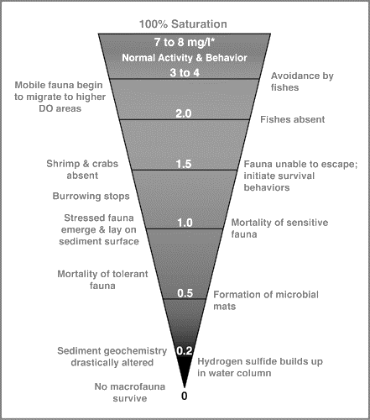

EXPERIMENT No.11: Biochemical Oxygen Demand

* General Discussion:-
* Most natural waters contain small quantities of [organic compounds](http://en.wikipedia.org/wiki/Organic_compound). Aquatic [microorganisms](http://en.wikipedia.org/wiki/Microorganisms) have evolved to use some of these compounds as [food](http://en.wikipedia.org/wiki/Food). About one-third of the food bacteria consumed becomes the solid organic cell material of the organisms. Theother two-thirds is oxidized to carbon dioxide and water by the biochemical action of the bacteria on the oxygendissolved in the water.
* Microorganisms living in oxygenated waters use dissolved oxygen to oxidatively degrade the organic compounds, releasing [energy](http://en.wikipedia.org/wiki/Energy) that is used for [growth](http://en.wikipedia.org/wiki/Bacterial_growth) and [reproduction](http://en.wikipedia.org/wiki/Reproduction). Populations of these microorganisms tend to increase in proportion to the amount of food available. This microbial [metabolism](http://en.wikipedia.org/wiki/Metabolism) creates an oxygen demand proportional to the amount of organic compounds useful as food.
* Under some circumstances, microbial metabolism can consume dissolved oxygen faster than atmospheric oxygen can dissolve into the water or the autotrophic community (algae, cyanobacteria and macrophytes) can produce. Fish and aquatic insects may die when oxygen is depleted by microbial metabolism.
* **Biochemical Oxygen Demand** or **B.O.D** is the amount of [dissolved oxygen](http://en.wikipedia.org/wiki/Oxygenation_(environmental)) needed by aerobic biological organisms in a body of water to break down organic material present in a given water sample at certain temperature over a specific time period. The term also refers to a chemical procedure for determining this amount. This is not a precise quantitative test, although it is widely used as an indication of the organic quality of water.
* Factors affected the BOD value:

1. Temperature @ 20℃.
2. O2fully saturated.
3. pH (6.5 to 8.5).
4. Free of toxic.
5. Seed.
6. Trace element (k, Cl, Ca P…).
7. Nutrient (12.5%-2.5%).

* The environmental impacts of BOD are:

1. Sewage containing high BOD create environmental and health problems.
2. It interferes with the aquatic life. Organic pollution is harmful to fish as it tends to reduce the amount of dissolved oxygen.
3. It defines the strength of domestic wastes and industrial wastewaters.

* The BOD value is most commonly expressed in milligrams of oxygen consumed per liter of sample during five days of incubation at 20°C and is often used as a robust surrogate of the degree of organic [pollution of water](http://en.wikipedia.org/wiki/Water_pollution).
* When BOD levels are high, dissolved oxygen (DO) levels decrease because the bacteria are consuming the oxygen that is available in the water. Since less dissolved oxygen is available in the water, fish and other aquatic organisms may not survive.
* At roomtemperature, the amount of oxygen dissolved in water is8mg/l. At freezing, it increases to 14.6mg/l; it alsoincreases at high barometric pressures (low altitudes). Atthe boiling point, the solubility of oxygen is zero.
* Significance:-
* BOD can be used as a gauge of the effectiveness of [wastewater treatment](http://en.wikipedia.org/wiki/Sewage_treatment) plants.
* BOD is similar in function to [chemical oxygen demand](http://en.wikipedia.org/wiki/Chemical_oxygen_demand) (COD), in that both measure the amount of [organic compounds](http://en.wikipedia.org/wiki/Organic_compound) in water. However, COD is less specific, since it measures everything that can be chemically oxidized, rather than just levels of biologically active organic matter.
* Reagents:-

The only reagents required are for the preparation of dilution water. All must be discarded if there is any sign if biological growth in the bottles:

1. Phosphate buffer solution.
2. Magnesium sulfate solution.
3. Calcium chloride solution.

* Analytical Method:-
* For all the samples incubation is at 20℃for five days.
* There are two commonly recognized methods for the measurement of BOD:

1. Direct method.
2. Dilution method.

* Procedure-Undiluted Samples:-

1. Bring the temperature of the sample to around 20℃.
2. Agitatevigorously to bring the D.O. level up or down to 100% saturation.
3. Fill two 300ml glass bottles with the sample in precisely the same way, care being taken to ensure that the bottles are completely filled and without bubbles when stoppered.
4. One bottle is incubated for five days at 20℃.
5. Measure the D.O. for the second bottle immediately.

(If it is not practicable to complete this D.O. analysis promptly the reagents must be added and the bottle shaken; see D.O. experiment).

1. Measure the D.O. for the incubated portion of sample after 5 days

$$B.O.D={D.O.}_{Final}-{D.O.}_{Initial}=mg/l$$

* To accept the results for the direct method:

1. Min. conc. during incubation period 1mg/l.
2. Min. D.O consumption 2mg/l for reliability.

* Procedure-Diluted Samples:-
* General Overview:
* Grossly polluted waters & wastes need dilution.
* If the estimated B.O.D is very large dilute the sample using appropriate dilution factor (ex. D.F.= 1/100; put 1ml of the sample and 99ml of dilution water)
* Dilution water:

1. Should not contain organic matter.
2. Prepared from distilled water.
3. Contains buffer and inorganic nutrients.
4. Saturated with D.O.

* Seed must be used in this method;

1. Provides microorganisms to oxidize organic matter.
2. Not required for; (municipal wastes, biologically treated effluents, surface water samples).
3. Source of seed:Settled sewage, Soil culture, receiving water.

* Sample Preparation and Procedure:

1. Dilute the sample with the specified D.F.; (ex: D.F.=1/100 for 300ml bottle add 3ml of the wastewater and fill the bottle with dilution water).
2. Fill six 300ml glass bottles with the diluted sample similar to the previous step in precisely the same way, care being taken to ensure that the bottles are completely filled and without bubbles when stoppered.
3. Add seed to the bottles.
4. Mix the diluted samples well.
5. Bring the samples to 20℃.
6. Agitate to bring the D.O. up or down to 100% saturation.
7. Prepare a blank sample; that contains two bottles filled with diluted water and seed only.
8. Measures the D.O. for one bottle for each the diluted sample and the blank sample immediately by adding the reagents (see D.O. experiment).
9. Put the other samples into the incubator at 20℃.
10. Measure the D.O. for the remaining bottles of the diluted sample; for each day one bottle.
11. Measure the D.O. of the remaining bottle of the blank sample after five days

$$B.O.D=\left[{\left(D.O._{0}-D.O._{5}\right)}_{Sample}-\left(\frac{x-1}{x}\right)*{\left(D.O._{0}-D.O._{5}\right)}_{Blank}\right]*X$$

Where X: Dilution factor.

* B.O.D Level:-

|  |  |
| --- | --- |
| BOD Level (mg/l) | Status |
| 1-2 | Clean water with little organic waste |
| 3-5 | Moderately clean water with some organic waste |
| 5-9 | Lots of organic material and many bacteria |
| >10 | Very poor water quality. Large amounts of organic material in the water. |

* NOTE: Generally, when BOD levels are high, there is a decline in DO levels. This is because the demand for oxygen by the bacteria is high and they are taking that oxygen from the oxygen dissolved in the water. If there is no organic waste present in the water, there will not be as many bacteria present to decompose it and thus the BOD will tend to be lower and the DO level will tend to be higher.
* At high BOD levels, organisms such as macro invertebrates that are more tolerant of lower dissolved oxygen (i.e. leeches and sludge worms) may appear and become numerous. Organisms that need higher oxygen levels (i.e. caddisfly larvae and mayfly nymphs) will NOT survive.

EXPERIMENT No.12: Chemical Oxygen Demand

* General Discussion:-
* Chemical oxygen demand (C.O.D) is a [standard](http://www.businessdictionary.com/definition/standard.html) [method](http://www.businessdictionary.com/definition/method.html) for indirect [measurement](http://www.businessdictionary.com/definition/measurement.html) of the [amount](http://www.businessdictionary.com/definition/amount.html) of [pollution](http://www.businessdictionary.com/definition/pollution.html) (that cannot be oxidized biologically) in a [sample](http://www.businessdictionary.com/definition/sample.html) of water.
* The chemical oxygen demand [test procedure](http://www.businessdictionary.com/definition/test-procedure.html) is based on the chemical [decomposition](http://www.businessdictionary.com/definition/decomposition.html) of [organic](http://www.businessdictionary.com/definition/organic.html) and [inorganic](http://www.businessdictionary.com/definition/inorganic.html) [contaminants](http://www.businessdictionary.com/definition/contaminant.html), dissolved or suspended in water.
* The [result](http://www.businessdictionary.com/definition/result.html) of a chemical oxygen demand [test](http://www.businessdictionary.com/definition/test.html) indicates the amount of water-dissolved oxygen (expressed as [parts per million](http://www.businessdictionary.com/definition/parts-per-million-PPM.html) or [milligrams](http://www.businessdictionary.com/definition/milligram.html) per [liter](http://www.businessdictionary.com/definition/liter.html) of water) consumed by the contaminants, during two hours of decomposition from a [solution](http://www.businessdictionary.com/definition/solution.html) of boiling potassium dichromate.
* The higher the chemical oxygen demand, the higher the amount of pollution in the test sample.
* For the contaminants that can be oxidized biologically, the [biological oxygen demand (B.O.D)](http://www.businessdictionary.com/definition/biological-oxygen-demand-BOD.html) method is used.
* Analytical Method:-
* The test measures the oxygen consumed from a mixture of boiling potassium dichromate / sulphuric acid solution by a sample, especially of polluted water or wastewater.
* When wastes are being analyzed, they should be homogenized in a blender before a portion is taken for analysis.
* Mercuric sulphate is added to counter chloride interference and silver sulphate is added to catalyze the oxidation of certain classes of compounds.
* The method given is applicable for samples of waters and wastes with a COD of 50mg/l upwards and with a chloride level below 200mg/l.
* Chemistry:-
* Organic matter is oxidized by acid dichromate to given carbine dioxin and water (in cases of total oxygen). This may be represented approximately by the “unbalanced” equation:
$$CH_{X}+Cr_{2}0_{7}^{-2}→CO_{2}+H_{2}O+Cr^{+2}$$

* The excess dichromate is titrated with Ferrous Ammonium Sulfate until at the end point a red color is developed by the ferroin indicator and excess Ferrous ion:
$$6Fe^{+2}+Cr_{2}O_{7}^{-2}+I_{4}H^{+}→6Fe^{+3}+2Cr^{+3}+7H_{2}O$$

$$\begin{matrix}Fe{\left(C_{12}H_{8}N_{2}\right)}_{3}^{+3} \\ Blue\end{matrix}+Fe^{+2}→\begin{matrix}Fe{\left(C_{12}H_{8}N_{2}\right)}_{3}^{+2} \\ Bload red\end{matrix}+Fe^{+3}$$

* Procedure:-

1. Take 10ml of the sample.
2. Add 0.2g of HgSO4.
3. Add 10ml of (H2SO4 + AgSO4).
4. Add 5ml of K2Cr2O7.
5. Add 5ml of (H2SO4 + AgSO4).
6. Heat the sample for two hours @ 150℃.
7. Prepare a blank sample by adding the same chemicals.
8. After two hours take the samples and dilute them to (60-70ml) by adding distilled water.
9. Titrate the sample(the remainingdichromate) with Ferrous Ammonium Sulphate until reaching the end point; a reddish brown color.
10. Record the volume of titrant used (B).
11. Titrate the blank sample (5ml of dichromate) with Ferrous Ammonium Sulphate until reaching the end point a reddish brown color.
12. Record the volume of titrant used (A).

* Calculations of Results:-

$$COD=\frac{\left(A-B\right)*N*8000*D.F}{ml of sample}$$

Where:

* A: volume of titrant reacts with the 5ml of dichromate.
* B: volume of titrant reacts with the remaining of dichromate.
* V: volume of the original sample.

EXPERIMENT No.13: Coliform

* General Discussion:-
* The discharge of wastes from municipal sewers is one of the most important water quality issues worldwide. It is of particular significance to sources of drinking water. Municipal sewage contains human faeces and water contaminated with these effluents may contain pathogenic (disease-causing) organisms and, consequently, may be hazardous to human health if used as drinking water or in food preparation. Faecal contamination of water is routinely detected by microbiological analysis.
* It is impractical to attempt the routine isolation of pathogens because they are present in relatively small numbers compared with other types of microorganism. Moreover, there are many types of pathogen and each requires a unique microbiological isolation technique. The approach that has been adopted is to analyze for indicator organisms that inhabit the gut in large numbers and are excreted in human faeces. The presence of these indicator organisms in water is evidence of Faecal contamination and, therefore, of a risk that pathogens are present. If indicator organisms are present in large numbers, the contamination is considered to be recent and/or severe.
* Bacteria in water are, in general, not present individually, but as clumps or in association with particulate matter. When enumerating bacteria in water it is not the number of individual bacteria present that are counted, but the number of clumps of bacteria or the particles and their associated bacteria. Each clump or particle may have many bacteria associated with it.
* The term “total coliforms” refers to a large group of Gram-negative, rod-shaped bacteria that share several characteristics. The group includes thermo-tolerant coliforms and bacteria of faecal origin, as well as some bacteria that may be isolated from environmental sources. Thus, the presence of total coliforms may or may not indicate faecal contamination. In extreme cases, a high count for the total coliform group may be associated with a low, or even zero, count for thermo-tolerant coliforms. Such a result would not necessarily indicate the presence of faecal contamination. It might be caused by entry of soil or organic matter into the water or by conditions suitable for the growth of other types of coliform. In the laboratory total coliforms are grown in or on a medium containing lactose, at a temperature of 35 or 37°C. They are provisionally identified by the production of acid and gas from the fermentation of lactose.
* The degree of coliform must be in water is equal to zero.
* 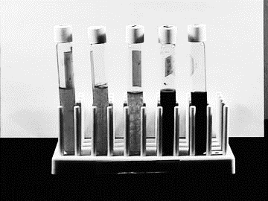Analytical method:-

1. Multiple fermentation tube technique:   
   The multiple tube fermentation method, also called most probable number, or MPN, is a common means of calculating the number of coliforms present in 100ml of a sample. The procedure determines both total coliform counts and Escherichia coli counts.
2. Membrane filters technique.

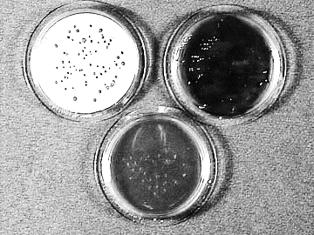The membrane filter technique is extremely useful in monitoring drinking water and a variety of natural waters. As related to the membrane filter technique, the coliform group may be defined as comprising all aerobic and many facultative anaerobic, gram-negative, non-spore forming, rod-shaped bacteria that develop a red colony with a metallic sheen. Some members of the total coliform group may produce a dark red or nucleated colony without a metallic sheen.

|  |  |
| --- | --- |
| Multiple Fermentation Tube technique | Membrane Filter technique |
| Slower: requires 48 hours for a positive | More rapid: quantitative results in or presumptive positive about 18 hours |
| More labor-intensive | Less labor-intensive |
| Requires more culture medium | Requires less culture medium |
| Requires more glassware | Requires less glassware |
| More sensitive | Less sensitive |
| Result obtained indirectly by statistical approximation (low precision) | Results obtained directly by colony count (high precision) |
| Not readily adaptable for use in the field | Readily adapted for use in the field |
| Applicable to all types of water | Not applicable to turbid waters |
| Consumables readily available in most countries | Cost of consumables is high in many countries |

Index and 95% confidence limits for various combinations of positive results when five tubes are used per dilution (10ml, 1ml and 0.1mlportion of sample):

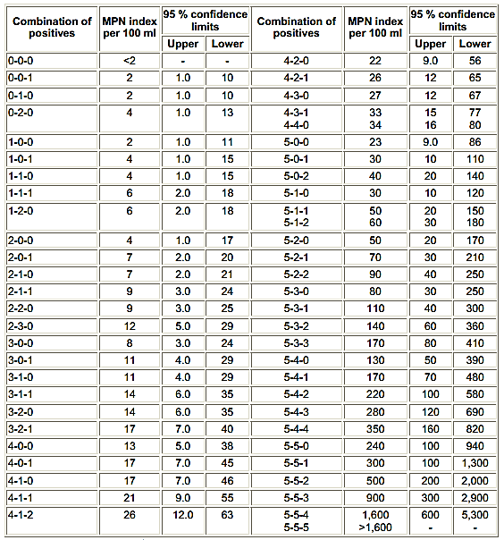

Student

Notes

Subject: Date:

______________________________________________________________________________________________________________________________________________________________________________________________________________________________________________________________________________________________________________________________________________________________________________________________________________________________________________________________________________________________________________________________________________________________________________________________________________________________________________________________________________________________________________________________________________________________________________________________________________________________________________________________________________________________________________________________________________________________________________________________________________________________________________________________________________________________________________________________________________________________________________________________________________________________________________________________________________________________________________________________________________________________________________________________________________________________________________________________________________________________________________________________________________________________________________________________________________________________________________________________________________________________________________________________________________________________________________________________________________________________________________________________________________________________________________________________________________________________________________________________________________________________________________________________________________________________________________________________________________________________________________________________________________________________________________________________________________________________________________________________________________________________________________________

Subject: Date:

______________________________________________________________________________________________________________________________________________________________________________________________________________________________________________________________________________________________________________________________________________________________________________________________________________________________________________________________________________________________________________________________________________________________________________________________________________________________________________________________________________________________________________________________________________________________________________________________________________________________________________________________________________________________________________________________________________________________________________________________________________________________________________________________________________________________________________________________________________________________________________________________________________________________________________________________________________________________________________________________________________________________________________________________________________________________________________________________________________________________________________________________________________________________________________________________________________________________________________________________________________________________________________________________________________________________________________________________________________________________________________________________________________________________________________________________________________________________________________________________________________________________________________________________________________________________________________________________________________________________________________________________________________________________________________________________________________________________________________________________________________________________________________________

Subject: Date:

______________________________________________________________________________________________________________________________________________________________________________________________________________________________________________________________________________________________________________________________________________________________________________________________________________________________________________________________________________________________________________________________________________________________________________________________________________________________________________________________________________________________________________________________________________________________________________________________________________________________________________________________________________________________________________________________________________________________________________________________________________________________________________________________________________________________________________________________________________________________________________________________________________________________________________________________________________________________________________________________________________________________________________________________________________________________________________________________________________________________________________________________________________________________________________________________________________________________________________________________________________________________________________________________________________________________________________________________________________________________________________________________________________________________________________________________________________________________________________________________________________________________________________________________________________________________________________________________________________________________________________________________________________________________________________________________________________________________________________________________________________________________________________________

Subject: Date:

______________________________________________________________________________________________________________________________________________________________________________________________________________________________________________________________________________________________________________________________________________________________________________________________________________________________________________________________________________________________________________________________________________________________________________________________________________________________________________________________________________________________________________________________________________________________________________________________________________________________________________________________________________________________________________________________________________________________________________________________________________________________________________________________________________________________________________________________________________________________________________________________________________________________________________________________________________________________________________________________________________________________________________________________________________________________________________________________________________________________________________________________________________________________________________________________________________________________________________________________________________________________________________________________________________________________________________________________________________________________________________________________________________________________________________________________________________________________________________________________________________________________________________________________________________________________________________________________________________________________________________________________________________________________________________________________________________________________________________________________________________________________________________________

Subject: Date:

______________________________________________________________________________________________________________________________________________________________________________________________________________________________________________________________________________________________________________________________________________________________________________________________________________________________________________________________________________________________________________________________________________________________________________________________________________________________________________________________________________________________________________________________________________________________________________________________________________________________________________________________________________________________________________________________________________________________________________________________________________________________________________________________________________________________________________________________________________________________________________________________________________________________________________________________________________________________________________________________________________________________________________________________________________________________________________________________________________________________________________________________________________________________________________________________________________________________________________________________________________________________________________________________________________________________________________________________________________________________________________________________________________________________________________________________________________________________________________________________________________________________________________________________________________________________________________________________________________________________________________________________________________________________________________________________________________________________________________________________________________________________________________________

Subject: Date:

______________________________________________________________________________________________________________________________________________________________________________________________________________________________________________________________________________________________________________________________________________________________________________________________________________________________________________________________________________________________________________________________________________________________________________________________________________________________________________________________________________________________________________________________________________________________________________________________________________________________________________________________________________________________________________________________________________________________________________________________________________________________________________________________________________________________________________________________________________________________________________________________________________________________________________________________________________________________________________________________________________________________________________________________________________________________________________________________________________________________________________________________________________________________________________________________________________________________________________________________________________________________________________________________________________________________________________________________________________________________________________________________________________________________________________________________________________________________________________________________________________________________________________________________________________________________________________________________________________________________________________________________________________________________________________________________________________________________________________________________________________________________________________________

Subject: Date:

______________________________________________________________________________________________________________________________________________________________________________________________________________________________________________________________________________________________________________________________________________________________________________________________________________________________________________________________________________________________________________________________________________________________________________________________________________________________________________________________________________________________________________________________________________________________________________________________________________________________________________________________________________________________________________________________________________________________________________________________________________________________________________________________________________________________________________________________________________________________________________________________________________________________________________________________________________________________________________________________________________________________________________________________________________________________________________________________________________________________________________________________________________________________________________________________________________________________________________________________________________________________________________________________________________________________________________________________________________________________________________________________________________________________________________________________________________________________________________________________________________________________________________________________________________________________________________________________________________________________________________________________________________________________________________________________________________________________________________________________________________________________________________________

Subject: Date:

______________________________________________________________________________________________________________________________________________________________________________________________________________________________________________________________________________________________________________________________________________________________________________________________________________________________________________________________________________________________________________________________________________________________________________________________________________________________________________________________________________________________________________________________________________________________________________________________________________________________________________________________________________________________________________________________________________________________________________________________________________________________________________________________________________________________________________________________________________________________________________________________________________________________________________________________________________________________________________________________________________________________________________________________________________________________________________________________________________________________________________________________________________________________________________________________________________________________________________________________________________________________________________________________________________________________________________________________________________________________________________________________________________________________________________________________________________________________________________________________________________________________________________________________________________________________________________________________________________________________________________________________________________________________________________________________________________________________________________________________________________________________________________________

Subject: Date:

______________________________________________________________________________________________________________________________________________________________________________________________________________________________________________________________________________________________________________________________________________________________________________________________________________________________________________________________________________________________________________________________________________________________________________________________________________________________________________________________________________________________________________________________________________________________________________________________________________________________________________________________________________________________________________________________________________________________________________________________________________________________________________________________________________________________________________________________________________________________________________________________________________________________________________________________________________________________________________________________________________________________________________________________________________________________________________________________________________________________________________________________________________________________________________________________________________________________________________________________________________________________________________________________________________________________________________________________________________________________________________________________________________________________________________________________________________________________________________________________________________________________________________________________________________________________________________________________________________________________________________________________________________________________________________________________________________________________________________________________________________________________________________________

Subject: Date:

______________________________________________________________________________________________________________________________________________________________________________________________________________________________________________________________________________________________________________________________________________________________________________________________________________________________________________________________________________________________________________________________________________________________________________________________________________________________________________________________________________________________________________________________________________________________________________________________________________________________________________________________________________________________________________________________________________________________________________________________________________________________________________________________________________________________________________________________________________________________________________________________________________________________________________________________________________________________________________________________________________________________________________________________________________________________________________________________________________________________________________________________________________________________________________________________________________________________________________________________________________________________________________________________________________________________________________________________________________________________________________________________________________________________________________________________________________________________________________________________________________________________________________________________________________________________________________________________________________________________________________________________________________________________________________________________________________________________________________________________________________________________________________________

Subject: Date:

______________________________________________________________________________________________________________________________________________________________________________________________________________________________________________________________________________________________________________________________________________________________________________________________________________________________________________________________________________________________________________________________________________________________________________________________________________________________________________________________________________________________________________________________________________________________________________________________________________________________________________________________________________________________________________________________________________________________________________________________________________________________________________________________________________________________________________________________________________________________________________________________________________________________________________________________________________________________________________________________________________________________________________________________________________________________________________________________________________________________________________________________________________________________________________________________________________________________________________________________________________________________________________________________________________________________________________________________________________________________________________________________________________________________________________________________________________________________________________________________________________________________________________________________________________________________________________________________________________________________________________________________________________________________________________________________________________________________________________________________________________________________________________________

Subject: Date:

______________________________________________________________________________________________________________________________________________________________________________________________________________________________________________________________________________________________________________________________________________________________________________________________________________________________________________________________________________________________________________________________________________________________________________________________________________________________________________________________________________________________________________________________________________________________________________________________________________________________________________________________________________________________________________________________________________________________________________________________________________________________________________________________________________________________________________________________________________________________________________________________________________________________________________________________________________________________________________________________________________________________________________________________________________________________________________________________________________________________________________________________________________________________________________________________________________________________________________________________________________________________________________________________________________________________________________________________________________________________________________________________________________________________________________________________________________________________________________________________________________________________________________________________________________________________________________________________________________________________________________________________________________________________________________________________________________________________________________________________________________________________________________________

Subject: Date:

______________________________________________________________________________________________________________________________________________________________________________________________________________________________________________________________________________________________________________________________________________________________________________________________________________________________________________________________________________________________________________________________________________________________________________________________________________________________________________________________________________________________________________________________________________________________________________________________________________________________________________________________________________________________________________________________________________________________________________________________________________________________________________________________________________________________________________________________________________________________________________________________________________________________________________________________________________________________________________________________________________________________________________________________________________________________________________________________________________________________________________________________________________________________________________________________________________________________________________________________________________________________________________________________________________________________________________________________________________________________________________________________________________________________________________________________________________________________________________________________________________________________________________________________________________________________________________________________________________________________________________________________________________________________________________________________________________________________________________________________________________________________________________________

Subject: Date:

______________________________________________________________________________________________________________________________________________________________________________________________________________________________________________________________________________________________________________________________________________________________________________________________________________________________________________________________________________________________________________________________________________________________________________________________________________________________________________________________________________________________________________________________________________________________________________________________________________________________________________________________________________________________________________________________________________________________________________________________________________________________________________________________________________________________________________________________________________________________________________________________________________________________________________________________________________________________________________________________________________________________________________________________________________________________________________________________________________________________________________________________________________________________________________________________________________________________________________________________________________________________________________________________________________________________________________________________________________________________________________________________________________________________________________________________________________________________________________________________________________________________________________________________________________________________________________________________________________________________________________________________________________________________________________________________________________________________________________________________________________________________________________________

Subject: Date:

______________________________________________________________________________________________________________________________________________________________________________________________________________________________________________________________________________________________________________________________________________________________________________________________________________________________________________________________________________________________________________________________________________________________________________________________________________________________________________________________________________________________________________________________________________________________________________________________________________________________________________________________________________________________________________________________________________________________________________________________________________________________________________________________________________________________________________________________________________________________________________________________________________________________________________________________________________________________________________________________________________________________________________________________________________________________________________________________________________________________________________________________________________________________________________________________________________________________________________________________________________________________________________________________________________________________________________________________________________________________________________________________________________________________________________________________________________________________________________________________________________________________________________________________________________________________________________________________________________________________________________________________________________________________________________________________________________________________________________________________________________________________________________________

Subject: Date:

______________________________________________________________________________________________________________________________________________________________________________________________________________________________________________________________________________________________________________________________________________________________________________________________________________________________________________________________________________________________________________________________________________________________________________________________________________________________________________________________________________________________________________________________________________________________________________________________________________________________________________________________________________________________________________________________________________________________________________________________________________________________________________________________________________________________________________________________________________________________________________________________________________________________________________________________________________________________________________________________________________________________________________________________________________________________________________________________________________________________________________________________________________________________________________________________________________________________________________________________________________________________________________________________________________________________________________________________________________________________________________________________________________________________________________________________________________________________________________________________________________________________________________________________________________________________________________________________________________________________________________________________________________________________________________________________________________________________________________________________________________________________________________________

Subject: Date:

______________________________________________________________________________________________________________________________________________________________________________________________________________________________________________________________________________________________________________________________________________________________________________________________________________________________________________________________________________________________________________________________________________________________________________________________________________________________________________________________________________________________________________________________________________________________________________________________________________________________________________________________________________________________________________________________________________________________________________________________________________________________________________________________________________________________________________________________________________________________________________________________________________________________________________________________________________________________________________________________________________________________________________________________________________________________________________________________________________________________________________________________________________________________________________________________________________________________________________________________________________________________________________________________________________________________________________________________________________________________________________________________________________________________________________________________________________________________________________________________________________________________________________________________________________________________________________________________________________________________________________________________________________________________________________________________________________________________________________________________________________________________________________________

Subject: Date:

______________________________________________________________________________________________________________________________________________________________________________________________________________________________________________________________________________________________________________________________________________________________________________________________________________________________________________________________________________________________________________________________________________________________________________________________________________________________________________________________________________________________________________________________________________________________________________________________________________________________________________________________________________________________________________________________________________________________________________________________________________________________________________________________________________________________________________________________________________________________________________________________________________________________________________________________________________________________________________________________________________________________________________________________________________________________________________________________________________________________________________________________________________________________________________________________________________________________________________________________________________________________________________________________________________________________________________________________________________________________________________________________________________________________________________________________________________________________________________________________________________________________________________________________________________________________________________________________________________________________________________________________________________________________________________________________________________________________________________________________________________________________________________________

Subject: Date:

______________________________________________________________________________________________________________________________________________________________________________________________________________________________________________________________________________________________________________________________________________________________________________________________________________________________________________________________________________________________________________________________________________________________________________________________________________________________________________________________________________________________________________________________________________________________________________________________________________________________________________________________________________________________________________________________________________________________________________________________________________________________________________________________________________________________________________________________________________________________________________________________________________________________________________________________________________________________________________________________________________________________________________________________________________________________________________________________________________________________________________________________________________________________________________________________________________________________________________________________________________________________________________________________________________________________________________________________________________________________________________________________________________________________________________________________________________________________________________________________________________________________________________________________________________________________________________________________________________________________________________________________________________________________________________________________________________________________________________________________________________________________________________________

Subject: Date:

______________________________________________________________________________________________________________________________________________________________________________________________________________________________________________________________________________________________________________________________________________________________________________________________________________________________________________________________________________________________________________________________________________________________________________________________________________________________________________________________________________________________________________________________________________________________________________________________________________________________________________________________________________________________________________________________________________________________________________________________________________________________________________________________________________________________________________________________________________________________________________________________________________________________________________________________________________________________________________________________________________________________________________________________________________________________________________________________________________________________________________________________________________________________________________________________________________________________________________________________________________________________________________________________________________________________________________________________________________________________________________________________________________________________________________________________________________________________________________________________________________________________________________________________________________________________________________________________________________________________________________________________________________________________________________________________________________________________________________________________________________________________________________________

Subject: Date:

______________________________________________________________________________________________________________________________________________________________________________________________________________________________________________________________________________________________________________________________________________________________________________________________________________________________________________________________________________________________________________________________________________________________________________________________________________________________________________________________________________________________________________________________________________________________________________________________________________________________________________________________________________________________________________________________________________________________________________________________________________________________________________________________________________________________________________________________________________________________________________________________________________________________________________________________________________________________________________________________________________________________________________________________________________________________________________________________________________________________________________________________________________________________________________________________________________________________________________________________________________________________________________________________________________________________________________________________________________________________________________________________________________________________________________________________________________________________________________________________________________________________________________________________________________________________________________________________________________________________________________________________________________________________________________________________________________________________________________________________________________________________________________________

Subject: Date:

______________________________________________________________________________________________________________________________________________________________________________________________________________________________________________________________________________________________________________________________________________________________________________________________________________________________________________________________________________________________________________________________________________________________________________________________________________________________________________________________________________________________________________________________________________________________________________________________________________________________________________________________________________________________________________________________________________________________________________________________________________________________________________________________________________________________________________________________________________________________________________________________________________________________________________________________________________________________________________________________________________________________________________________________________________________________________________________________________________________________________________________________________________________________________________________________________________________________________________________________________________________________________________________________________________________________________________________________________________________________________________________________________________________________________________________________________________________________________________________________________________________________________________________________________________________________________________________________________________________________________________________________________________________________________________________________________________________________________________________________________________________________________________________

Subject: Date:

______________________________________________________________________________________________________________________________________________________________________________________________________________________________________________________________________________________________________________________________________________________________________________________________________________________________________________________________________________________________________________________________________________________________________________________________________________________________________________________________________________________________________________________________________________________________________________________________________________________________________________________________________________________________________________________________________________________________________________________________________________________________________________________________________________________________________________________________________________________________________________________________________________________________________________________________________________________________________________________________________________________________________________________________________________________________________________________________________________________________________________________________________________________________________________________________________________________________________________________________________________________________________________________________________________________________________________________________________________________________________________________________________________________________________________________________________________________________________________________________________________________________________________________________________________________________________________________________________________________________________________________________________________________________________________________________________________________________________________________________________________________________________________________

Subject: Date:

______________________________________________________________________________________________________________________________________________________________________________________________________________________________________________________________________________________________________________________________________________________________________________________________________________________________________________________________________________________________________________________________________________________________________________________________________________________________________________________________________________________________________________________________________________________________________________________________________________________________________________________________________________________________________________________________________________________________________________________________________________________________________________________________________________________________________________________________________________________________________________________________________________________________________________________________________________________________________________________________________________________________________________________________________________________________________________________________________________________________________________________________________________________________________________________________________________________________________________________________________________________________________________________________________________________________________________________________________________________________________________________________________________________________________________________________________________________________________________________________________________________________________________________________________________________________________________________________________________________________________________________________________________________________________________________________________________________________________________________________________________________________________________________

Subject: Date:

______________________________________________________________________________________________________________________________________________________________________________________________________________________________________________________________________________________________________________________________________________________________________________________________________________________________________________________________________________________________________________________________________________________________________________________________________________________________________________________________________________________________________________________________________________________________________________________________________________________________________________________________________________________________________________________________________________________________________________________________________________________________________________________________________________________________________________________________________________________________________________________________________________________________________________________________________________________________________________________________________________________________________________________________________________________________________________________________________________________________________________________________________________________________________________________________________________________________________________________________________________________________________________________________________________________________________________________________________________________________________________________________________________________________________________________________________________________________________________________________________________________________________________________________________________________________________________________________________________________________________________________________________________________________________________________________________________________________________________________________________________________________________________________

Subject: Date:

______________________________________________________________________________________________________________________________________________________________________________________________________________________________________________________________________________________________________________________________________________________________________________________________________________________________________________________________________________________________________________________________________________________________________________________________________________________________________________________________________________________________________________________________________________________________________________________________________________________________________________________________________________________________________________________________________________________________________________________________________________________________________________________________________________________________________________________________________________________________________________________________________________________________________________________________________________________________________________________________________________________________________________________________________________________________________________________________________________________________________________________________________________________________________________________________________________________________________________________________________________________________________________________________________________________________________________________________________________________________________________________________________________________________________________________________________________________________________________________________________________________________________________________________________________________________________________________________________________________________________________________________________________________________________________________________________________________________________________________________________________________________________________________